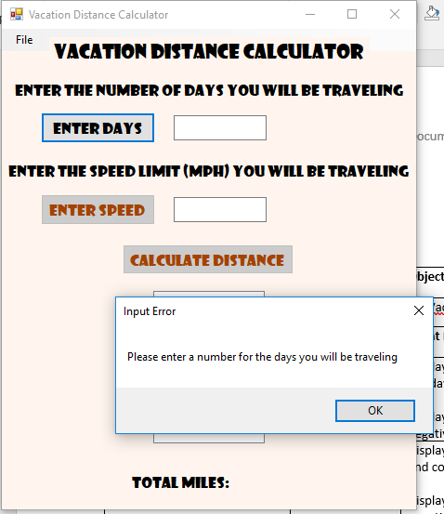 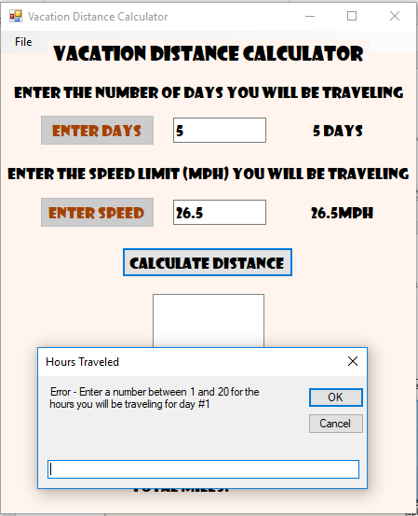

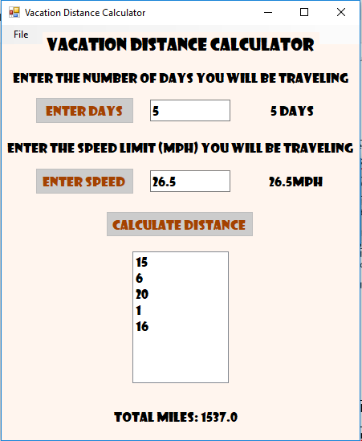

|  |  |  |  |
| --- | --- | --- | --- |
| **Program Name:** | **Developer:** | **Object:** | **Date**: |
| Vacation Distance Calculator | David Brungardt | frmVacationDistanceCalculator | December 3, 2017 |
| **Object** | **Event Trigger** | **Event Processing** | |
| btnDays | Click | Displays the days the user will be traveling and converts the days entry to a decimal  Display an error message if the entry is non-numeric or negative. | |
| btnMPH | Click | Displays the days speed limit (MPH) user will be traveling and converts the mph entry to a decimal  Display an error message if the entry is non-numeric or negative. | |
| btnCalculateTotalCost | Click | Display an InputBox object to obtain the amount of hours the user will be traveling each day.  Check if hours entry value is numeric, convert strHours to a Decimal value  If strHours is numeric, check to see that the value is between 0 and 20.  If the hours value is positive:  Display the value in lstTotalMiles  Accumulate the total of hours entered in decTotalHours  Update the number of entries  Set the InputBox message to the normal message  If the value entered is not numeric, display an error message in the input box  If the value entered is not positive, display an error message in the InputBox  After all the hour values are entered, change the Visible property of lblTotalMiles to true  If one., or more hour values are entered: Calculate the total miles traveled  Display the total hours in lblTotalMiles  If no values are entered:  Display the text “no hours value entered”  Disable the btnCalculateDistance button | |
| mnuClear | Click | Clear the lstTotalMiles ListBox  Change the Visible property of lblTotalMIles to false  Change the Visible Property of lblDays to false  Change the Visible Property of lblMPH to false  Enable the btnDays button  Disable the btnCalculateDistance button  Disable the btnMPH button | |
| mnuExit | Click | Exit the application | |
| frmVacationDistanceCalculator | Load | Set focus on txtDays | |

' Program Name: Vacation Distance Calculator

' Author: David Brungardt

' Date: 12/08/2017

' Purpose: The Vacation Distance Calculator program calculates

' and displays the total distance traveled based on days

' traveling, the speed limit, and the hours entered for

' each day. it displays the days traveled, the speed limit

' (mph) the minutes traveled each day. When the user is

Option Strict On

Public Class frmVacationDistanceCalculator

Private Sub Form1_Load(sender As Object, e As EventArgs) Handles MyBase.Load

' Sets the focus to txtDays

txtDays.Focus()

End Sub

Private Sub txtMPH_TextChanged(sender As Object, e As EventArgs) Handles txtMPH.TextChanged

End Sub

Private Sub btnDays_Click(sender As Object, e As EventArgs) Handles btnDays.Click

' This event handler allows the user to enter the number of days

' they will be traveling. It displays the number of days and

' disables the btnDays button

Dim decDays As Decimal

If IsNumeric(txtDays.Text) Then

decDays = Convert.ToDecimal(txtDays.Text)

If decDays > 0 Then

lblDays.Text = txtDays.Text & " Days"

lblDays.Visible = True

btnDays.Enabled = False

btnMPH.Enabled = True

txtMPH.Focus()

Else

MsgBox("Please enter a positive value for the days you will be traveling", , "Input Error")

txtDays.Focus()

End If

Else

MsgBox("Please enter a number for the days you will be traveling", , "Input Error")

txtDays.Focus()

End If

End Sub

Private Sub btnMPH_Click(sender As Object, e As EventArgs) Handles btnMPH.Click

' This event handler allows the user to enter the speed at which

' they will be traveling. It displays the speed limit (MPH) and

' disables the btnMPH button.

Dim decMPH As Decimal

If IsNumeric(txtMPH.Text) Then

decMPH = Convert.ToDecimal(txtMPH.Text)

If decMPH > 0 Then

lblMPH.Text = txtMPH.Text & "MPH"

lblMPH.Visible = True

btnMPH.Enabled = False

btnCalculateDistance.Enabled = True

btnCalculateDistance.Focus()

Else

MsgBox("Please enter a positive value for the speed limit (MPH) at which you'll be traveling", , "Input Error")

txtMPH.Focus()

End If

Else

MsgBox("Please enter a number for the speed limit (MPH) at which you'll be traveling", , "Input Error")

txtMPH.Focus()

End If

End Sub

Private Sub ClearToolStripMenuItem_Click(sender As Object, e As EventArgs) Handles mnuClear.Click

' the mnuClear click event clears the ListBox object and hides

' the average weight loss label. It also enables the btnDays button

lstTotalMiles.Items.Clear()

lblTotalMiles.Visible = False

lblDays.Visible = False

lblMPH.Visible = False

btnCalculateDistance.Enabled = False

btnMPH.Enabled = False

btnDays.Enabled = True

txtMPH.Text = ""

txtDays.Text = ""

txtDays.Focus()

End Sub

Private Sub ExitToolStripMenuItem_Click(sender As Object, e As EventArgs) Handles mnuExit.Click

'The mnuExit click event closes the window and exits the application

Close()

End Sub

Private Sub btnCalculateDistance_Click(sender As Object, e As EventArgs) Handles btnCalculateDistance.Click

' The btnCalculateDistance_Click event accepts and displays

' the hours traveled per day, it then calculates the total

' and displays the total distance traveled.

' Declare and initialize variables

Dim decDays = Convert.ToDecimal(txtDays.Text)

Dim decMPH = Convert.ToDecimal(txtMPH.Text)

Dim strHours As String

Dim decHours As Decimal

Dim decTotalHours As Decimal = 0D

Dim decTotalDistance As Decimal = 0D

Dim strInputMessage As String = "Enter the hours you will be traveling for day #"

Dim strInputHeading As String = "Hours Traveled"

Dim strNormalMessage As String = "Enter the hours you will be traveling for day #"

Dim strNonNumericError As String = "Error - Enter a number for the hours you will be traveling for day #"

Dim strNegativeError As String = "Error - Enter a number between 1 and 20 for the hours you will be traveling for day #"

' Declare and initialize loop variables

Dim strCancelClicked As String = ""

Dim decMaxNumberOfEntries = decDays

Dim intNumberOfEntries As Integer = 1

' This loop allows the user to enter the hours they will be driving

' for each day they will be traveling. The loop terminates when the

' user has entered a value for each day they will be traveling, or

' the user taps or clicks the Cancel button in the InputBox

strHours = InputBox(strInputMessage & intNumberOfEntries, strInputHeading, "")

Do Until intNumberOfEntries > decMaxNumberOfEntries Or strHours = strCancelClicked

If IsNumeric(strHours) Then

decHours = Convert.ToDecimal(strHours)

If decHours > 0 And decHours <= 20 Then

lstTotalMiles.Items.Add(decHours)

decTotalHours += decHours

intNumberOfEntries += 1

strInputMessage = strNormalMessage

Else

strInputMessage = strNegativeError

End If

Else

strInputMessage = strNonNumericError

End If

If intNumberOfEntries <= decMaxNumberOfEntries Then

strHours = InputBox(strInputMessage & intNumberOfEntries, strInputHeading, "")

End If

Loop

' Calculates and displays the total miles traveled

If intNumberOfEntries > 1 Then

lblTotalMiles.Visible = True

decTotalDistance = decTotalHours * decMPH

lblTotalMiles.Text = "Total Miles: " & decTotalDistance

Else

MsgBox("No hours value entered")

End If

'Disables Calculate Distance button

btnCalculateDistance.Enabled = False

End Sub

End Class